

**Deep Learning**

***Pneumonia Detection Using Image-Based Convolutional Neural Network***

***Team 7***

*Raditya Fahritama*

**School of Graduate Professional Studies**

Data Analytics

DAAN 570 – Deep Learning

*Fall Semester, 2022*

**TABLE OF CONTENTS**

**Introduction....................................................................................................................................2**

**Problem Statement........................................................................................................................2**

**Data Description............................................................................................................................2**

**Challenges.......................................................................................................................................2**

**Deep Learning Process.................................................................................................................4**

**Expected Results...........................................................................................................................4**

**References To Date Sources..........................................................................................................5**

**Related Works…………................................................................................................................5**

**Justification For Existing Code....................................................................................................5**

**References…………………...........................................................................................................6**

# Introduction

Pneumonia is an infection that inflames the air sacs in one or both lungs. The air sacs may fill with fluid or pus. causing cough with phlegm or pus, fever, chills, and difficulty breathing. A variety of organisms, including bacteria, viruses, and fungi, can cause pneumonia. Pneumonia can range in seriousness from mild to life-threatening. It is most serious for infants and young children, people older than age 65, and people with health problems or weakened immune systems. Each year, pneumonia affects about 450 million people globally (7% of the population) and results in about 4 million deaths. With the introduction of antibiotics and vaccines in the 20th century, survival has greatly improved. Nevertheless, pneumonia remains a leading cause of death in developing countries, and also among the very old, the very young, and the chronically ill. Pneumonia often shortens the period of suffering among those already close to death. Diagnosis is usually made based on recent health history (such as surgery, a cold, or travel exposures) and the extent of the illness. Pneumonia is typically diagnosed based on a combination of physical signs and often a chest X-ray. Chest X-ray (CXR) is a projection radiograph of the chest used to diagnose conditions affecting the chest, its contents, and nearby structures. Chest radiographs are the most common film taken in medicine. This project aims to diagnose whether someone has been infected with pneumonia based on the chest X-ray of the person. And we also want to classify whether the pneumonia is caused by bacteria or viruses based on the image.

# Problem Statement

The objective of our project is to analyze the patient’s chest X-ray and identify whether the patient has pneumonia or not and classifying the type of the pneumonia based on the image using CNN and other deep learning method.

# Data DESCRIPTION

We are using data that is provided from Kaggle. The dataset contains images of chest X-Ray that is focused on pneumonia diseases. The dataset itself was obtained from Mendeley that the original dataset contains the chest X-Ray data and Optical Coherence Tomography (OCT) for classification. But for this project, we will be using the chest X-Ray data only. The data was labeled as Normal and Pneumonia. And for the Pneumonia images, they are categorized again as Bacterial or Viral pneumonia. Chest X-ray images were selected from retrospective cohorts of pediatric patients of one to five years old from Guangzhou Women and Children’s Medical Center, Guangzhou. All chest X-ray imaging was performed as part of patients’ routine clinical care. For the analysis of chest x-ray images, all chest radiographs were initially screened for quality control by removing all low quality or unreadable scans. The diagnoses for the images were then graded by two expert physicians before being cleared for training the AI system. In order to account for any grading errors, the evaluation set was also checked by a third expert. Total images that are available in the dataset is 5856 images. The images pixels are around 1200 x 1000 pixels. The distribution of the images is not balanced with the bacterial pneumonia images have the most number out of the three categories. Below is example of the images of the normal, bacterial pneumonia, and viral pneumonia.

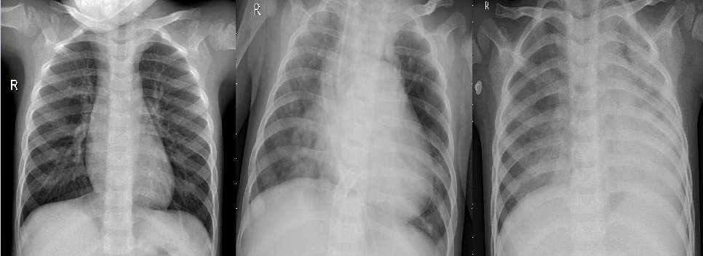

Figure 1: Example of Chest X-Ray, (left) Normal, (center) Bacterial Pneumonia, (right) Viral Pneumonia

# Challenges

**Imbalance Dataset that may lead to Biased Data**

The dataset that we have is imbalance. With the number of positive (Pneumonia) data having more samples than normal data. This may be a problem and may introduce bias in the classification. As Convolutional Neural Network works best when training data is balance, this problem may hinder the potential of the models that are proposed. We have to look for a way to deal with this imbalance data problem.

**There might be not enough data for creating a good model**

As we know, models that are based on Neural Network is data hungry. Meaning that they have to be fed many data so that we can get good results. The dataset contains total of around 5000 images. A model that relies only on this data might be not enough to create a good classifier because of lack of data. We have to find a way on how to deal with this.

# DEEP Learning process

We are planning to use Convolutional Neural Network (CNN) to diagnose the patient based on their CXR images. A Convolutional Neural Network (ConvNet/CNN) is a Deep Learning algorithm which can take in an input image, assign importance (learnable weights and biases) to various aspects/objects in the image and be able to differentiate one from the other. The pre-processing required in a ConvNet is much lower as compared to other classification algorithms. While in primitive methods filters are hand-engineered, with enough training, ConvNets have the ability to learn these filters/characteristics. Convolutional Neural Network is a specialized neural network for processing data that has an input shape like a 2D matrix like images. CNN's are typically used for image detection and classification. When there is problem that involves image identification, ConvNets is usually used and has become the standard solution to deal with the identification.

We are also going to be using Transfer Learning Technique as the approach to the identification. Transfer learning is a machine learning method where a model developed for a task is reused as the starting point for a model on a second task. By applying transfer learning to a new task, one can achieve significantly higher performance than training with only a small amount of data. Transfer learning is so common that it is rare to train a model for an image or natural language processing-related tasks from scratch. Transfer learning has the benefit of decreasing the training time for a neural network model and can result in lower generalization error.

We are considering these pre-trained models to be compared in our project:

* VGG
* Densenet
* Resnet
* Inception
* Xception

If along the way. Other deep learning methods are required to increase the project’s potential, we will add the additional processes for the finalized deliverables.

We will be experimenting with the train/test split ratio of the dataset. We will split the data for 50/50, 70/30, and 80/20. Then, we compare and see if these three ratios will make any difference in performance results. We also will evaluate every accuracy that is acquired through the process for each model. We will compare them one by one and see which of the model perform the best for this type of images. And we will see if our model can distinguish the pneumonia type based on the evaluated image.

# Expected Results

When it comes to expected results, we are expecting for the models to be able to identify and diagnose whether the patient has Pneumonia or not based on their Chest X-Ray images. And we expected our models to be able to classify whether the Pneumonia falls on the Bacterial Pneumonia category or Viral Pneumonia. We expect to get the accuracy of at least 80% to 92%. We think that this is the range of great accuracy for a model. If we get accuracy that is higher than the expected range for our models, it will be good. If we get accuracy that is lower than the expected range, we will try to reflect and recalibrate our models by tuning them to get the desired accuracy.

# References TO DATA SOURCES

* Kermany, Daniel; Zhang, Kang; Goldbaum, Michael (2018), “Labeled Optical Coherence Tomography (OCT) and Chest X-Ray Images for Classification”, Mendeley Data, V2, doi: 10.17632/rscbjbr9sj.2

# RELATED WORKS

* Puneet Gupta, “Pneumonia Detection Using Convolutional Neural Networks”, International Journal for Modern Trends in Science and Technology, Vol. 07, Issue 01, January 2021, pp.- 77-80.
* Yu, X., Wang, S.-H., & Zhang, Y.-D. (2021). CGNet: A graph-knowledge embedded convolutional neural network for detection of pneumonia. *Information Processing & Management*, *58*(1), 102411. https://doi.org/10.1016/j.ipm.2020.102411
* Rahman, T., Chowdhury, M. E., Khandakar, A., Islam, K. R., Islam, K. F., Mahbub, Z. B., Kadir, M. A., & Kashem, S. (2020). Transfer learning with deep convolutional neural network (CNN) for pneumonia detection using chest X-ray. *Applied Sciences*, *10*(9), 3233. https://doi.org/10.3390/app10093233

# Justification for USING Existing code

There are many models that are available online when it comes to Convolutional Neural Networks. There are many models that adopt technique and architecture that are similar to our proposed model and deep learning process. These codes will greatly help us to get the insight of the models. And these codes can be our benchmark to see if our models can go to the path that is directed similar to available codes so that the models don’t go too off the path. Existing codes that are already have good performance can also help us to build the model that is similarly great, or even better by modifying the code according to our needs and our specific project.

# References

Saha, S. (2018, December 17). *A comprehensive guide to Convolutional Neural Networks - the eli5 way*. Medium. Retrieved September 24, 2022, from https://towardsdatascience.com/a-comprehensive-guide-to-convolutional-neural-networks-the-eli5-way-3bd2b1164a53

Wikimedia Foundation. (2022, September 4). *Pneumonia*. Wikipedia. Retrieved September 24, 2022, from https://en.wikipedia.org/wiki/Pneumonia

Mayo Foundation for Medical Education and Research. (2020, June 13). *Pneumonia*. Mayo Clinic. Retrieved September 24, 2022, from https://www.mayoclinic.org/diseases-conditions/pneumonia/symptoms-causes/syc-20354204

*Pneumonia*. Johns Hopkins Medicine. (n.d.). Retrieved September 24, 2022, from https://www.hopkinsmedicine.org/health/conditions-and-diseases/pneumonia

Brownlee, J. (2019, September 16). *A gentle introduction to transfer learning for Deep learning*. Machine Learning Mastery. Retrieved September 24, 2022, from https://machinelearningmastery.com/transfer-learning-for-deep-learning/#:~:text=Transfer%20learning%20is%20an%20optimization,that%20has%20already%20been%20learned.

Lendave, V. (2021, September 1). *A comparison of 4 popular transfer learning models*. Analytics India Magazine. Retrieved September 24, 2022, from https://analyticsindiamag.com/a-comparison-of-4-popular-transfer-learning-models/